WWW.TADASTAGES.COM

MY STAGE: Information and Commitment Letter - Fall 2019

MANDATORY PARENT MEETINGS: Monday Sept 9th OR Friday Sept 13th, 7:15pm

Thank you for choosing TADA Stages to be your child’s performing arts, life- skills, and confidence building education. MyStage Musicals are designed to be a non-competitive, fun, and comprehensive musical theatre process.

Philosophy:
“Love art in yourself, and not yourself in the art.” ~ Constantin Stanislavski
This is a quote from one of the most influential acting teachers of our time and is a mantra we echo in our classrooms.

Building a production as a team can be very challenging for young people. Most children begin with particular expectations, such as wanting a certain role, or thinking each show and its content are exactly like the movie they saw or the book they read. Upon casting, many students can initially experience frustrations and disappointment if their expectations do not match the outcome. At TADA Stages, we take special care to use this experience as a platform for teaching and mentoring each child to grow and learn. We focus on learning to trust the process, eliminate negative assumptions, and handle disappointment in a positive way to create personal success. When these elements are imparted from the instructors as well as the parents, each child thrives in self-expression, teamwork, responsibility, confidence, peer-acceptance, self-acceptance, and an overall love of story and the performing arts.

REGISTRATION:
Registration has already been completed and your registration payment has already been charged to your card on file.

REHEARSALS, TECH REHEARSALS, and SHOWS:
All rehearsals and shows take place at TADA Stages, 2010 N. Sepulveda Blvd., Manhattan Beach (behind Manhattan Bread & Bagel/Fresh Bros. Pizza). This 4-month class performs two shows and will have either two or three tech rehearsals as listed on the following page:

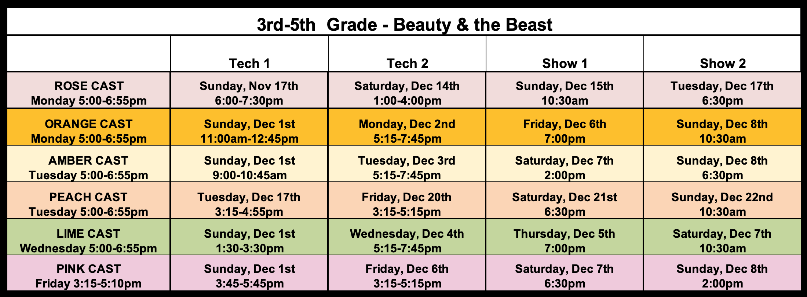

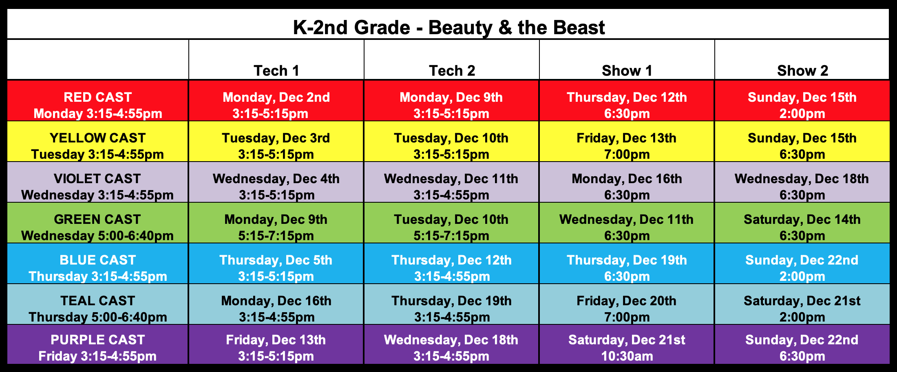

*ALL TECH REHEARSALS AND SHOWS ARE MANDATORY*

CONFLICTS
- Commitment: 100% attendance at all rehearsals is strongly expected in order to create the best learning environment for all in each cast. We love that your child knows their lines or parts so well you might feel that they can miss a day but, the problem is, the rest of the cast doesn’t know your child’s lines or parts. The whole cast suffers when their castmates aren’t there to practice with.
- Character: We are here to serve children and their development. That is why we have high attendance expectations. We understand family life and hectic schedules, but we also want to make sure we communicate that we value follow-through, dedication, and commitment. These are traits of great character we instill in our students through our practices.
- Responsibility: Acceptable Conflicts marked on the Conflict Calendar and turned in at the first rehearsal will be the only absences accepted outside of urgent situations or sickness. Only 2 Acceptable Conflicts per season will be permitted. We understand that things come up but want to teach our young actors that they have a responsibility to others as well as to themselves.
  - Examples of Acceptable Conflicts include but are not limited to graduations, weddings, funerals, school performances, performing arts competitions or currently scheduled soccer championships etc.
  - Examples of unacceptable conflicts include but are not limited to birthday parties, play dates, Disneyland excursions, or unexpected out of town guests etc.
- Accountability: If an absence does occur, we ask that parents help their young actor by reviewing the dance/song videos posted on Dropbox before the next rehearsal. It is always hard for young people to walk into a rehearsal where they don’t know the material.
- 3-5th Grade: We encourage absent cast members to get together and work with one another to learn staging, choreography, script and/or vocal changes that may have occurred during their absence.
- Punctuality: Performers must be at rehearsals on time. Excess tardiness and/or absences create anxiety in young people and can be disruptive to other cast mates.
- No peeking: All rehearsals are closed to everyone except the staff or parent volunteers (who may be working during the rehearsal process). Of course, exceptions are made for certain special circumstances.

CASTING & PLACEMENT
TRUST THE PROCESS.

TADA fosters teamwork and firmly believes that there are no small parts. Students will be informed of what they’ve been cast as soon as possible after the first few weeks of class, which allows Directors to work with students and determine appropriate placement.
    - The casting decisions made by the Director(s) are based on many factors and are ultimately influenced by what will be best for the entire production. We teach that the story we get to tell as a cast is the reason to do a show. Again, we focus on the entire whole picture and not just individual talent.
    - Please Trust Us: We have 15 other children to place in a cast and empower. Please trust us: We see your child and believe in them. Help us help them by showing what it looks like to trust the process and focus on the good rather than the bad. We expect all parents and students to support the casting decisions made by the Director(s). It’s just better for all that way.
    - Line Counting is Highly Discouraged: If one starts counting lines to compare with others, then one has missed the point of theatre all together.

CAST MEMBER BEHAVIOR EXPECTATIONS
Teamwork is the key to success of My Stage. We require commitment and cooperation from everyone involved. In order for TADA to provide a high-quality theatre experience to its students AND create a fun and stimulating environment within which to work, there are expectations for behavior that must be met. The following behaviors will be expected during all My Stage rehearsals and productions.
- Display the highest standards of respect for self and others.
- Pay attention and follow the requests of staff, parents, and supervisors at all times.
- Be prepared – know your lines, choreography, staging and be off-book when required. Mom, dad, siblings, grandparents, nannies, and friends can help!
- No excessive talking and disruptive behavior. This is disrespectful to your instructors and fellow cast members.
- There is no talking about other students or gossiping about one another during rehearsals. We are a team that supports each other 100%, enabling everyone to be their most creative selves.
- No exploring. Do not leave the rehearsal/theatre premises without supervision. You must wait inside for your ride to pick you up.
- Please honor and respect our rehearsal space. It helps us have fun!
- Food and drinks are only allowed during designated break times.
- There is no eating or drinking in costume.
- You must inform your instructor of any illness or injury before rehearsals begin or if they occur during rehearsal.
- Remember you have to give to get! Give of yourself and be kind and you will receive the same in return.

SUPPORT FROM PARENTS
- Display support for your child and other cast members in the role that they have earned at all rehearsals and at all performances.
- Do not criticize or gossip about TADA cast members, other parents, teachers, staff or volunteers at any TADA Studios. This isn’t the environment we are trying to foster here. If you have a concern, please contact Julia Mirkovich (julia@tadastages.com) directly and discreetly.
- We will help you help your actor by giving you useful tips on how to practice/study lines, songs, and dance numbers with them. They are pretty amazing people who can remember far more than us but need a little help getting there.
- Just a reminder...let’s all, as parents, remember to be mindful that our young people are processing, learning, and are in development. That’s their rite of passage. It’s so cool when we let them figure out how very capable they are through the act of trial and error, trial and error, then trial and succeed! The art of “getting back up on the horse” is our greatest ability.

GENERAL POLICIES
- Parents must notify staff regarding any special circumstances or medical requirements related to their child.
- Parents/guardians must check for adult supervision before leaving their participants at rehearsals.
- Parents/guardians must pick-up their participant at the designated time and no later.
- No video or photography is allowed during Tech Week without the prior approval of the director.
- No open-toed shoes are to be worn at rehearsals or the theatre venue. Wear jazz or tennis shoes and comfy clothing that is easy to move in. Hair must be pulled back in a ponytail or away from the face.

COSTUMES
Your costume fee has been bundled in your fees and is not charged separately. Costumes remain the property of TADA STAGES. There are pieces of clothing that you may need to provide such as:
- Jazz shoes, undergarments for quick changing like leotards and bootie shorts, boots, socks, leggings etc.
- Costume fittings take place during rehearsals. Costumes are provided in the dressing room during Tech Week. Costumes are not to be removed from the studio without the prior approval of the Costumers.
- In the event a costume is damaged due to negligence or misuse, the resulting cost to repair or replace the costume will be the responsibility of the cast member.
- It is the cast member’s responsibility to keep his/her costume(s) clean for all performances. If a costume becomes soiled or badly wrinkled during Tech week or show weekends, the cast member may be asked to take his/her costume(s) home for cleaning and pressing. In these instances, the costume must be ready for use by the next rehearsal or performance.

TUITION & SHOW TICKETS
Tuition, tech/show snacks and meals, and costumes have been bundled together. All Fees are non- refundable and will be charged as follows:
- Your tuition will be charged to your card on file as scheduled in our payment policies. If you have not been charged, then you have received an email from Mark with a request to update your card on file.
- With a maximum of 16 students per cast, our My Stage classes regularly sell out and are wait listed because they offer an intimate opportunity for our performers to learn, grow, and become stronger. Any withdrawal of a student from the cast, creates a serious setback for everyone as every single part is important and affects the other. Therefore, if you withdraw for any reason after the cast list is posted, TADA STAGES will charge you the entire tuition for the season. If withdrawal occurs before the cast list is posted then you will not be charged the second half of tuition.
- Each child is allotted 5 tickets for each performance. Any additional tickets which are not purchased will be sold first come/ first serve 7 days prior to the show dates. Tickets, dvd’s, and t-shirts are not mandatory purchases, but are optional.

OPTIONAL ITEMS

T-SHIRTS - As stated above, T-shirts, will be available for sale. Based upon popular demand, order forms will be passed out on the first and second class day. Orders must be placed and given in person to
the office by Friday, Sept 20th. T-Shirts are $25.00 and payments will be billed to your card on file.
This is your only opportunity to order a T-Shirt for the Fall season!

DVDS – As stated above, DVDs will be available for sale. Order information will be provided 4 weeks prior to show time.

TADA STAGES WEBSITE AND EMAILS!
WEBSITE AND EMAILS!
Please visit www.TADAStages.com for all TECH/REHEARSAL/ PERFORMANCE info. We also have new emails. Emails will be coming from the Tada Stages emails. Below you will find all staff emails:

TADA Stages Owner/Business Manager: mark@tadastages.com
TADA Stages Owner/Education Director: julia@tadastages.com
My Stage-Managing Director mary@tadastages.com
MyStage Producer chloe@tadastages.com
TADA Stages Office Manager: victoria@tadastages.com

CONFLICT SHEET:

STUDENT NAME: ______________________________________________________________________________________________

CLASS COLOR/DAY/TIME: ___________________________________________________________________________________

CONFLICTS:
Please find your child’s class; fill in all known conflicts. Please check box below if you have no conflicts. Hand in at Parent Meeting or first-class day. Please know that we take into consideration students conflicts when creating the rehearsal schedule. It’s vital to the success and readiness of the each cast.

CLASS DATE | - if you have a conflict | DESCRIBE CONFLICT: (e.g. vacation, dentist, etc)

No Conflicts Exist :

Parent Signature

Parent Name (Print)

